Summary of ITECH-3101

week 1 _ Lab Exercise

Created by: Boris Wijaya (30393908)

Exercise of Project 1

In this project, I learn how to import Excel data files to create a SAS data set. After opening SAS studio I’m selecting the upload icon shown below.

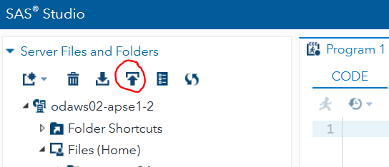

Then it will show the below screen where I must the “Grades.xls” files from my computer to upload.

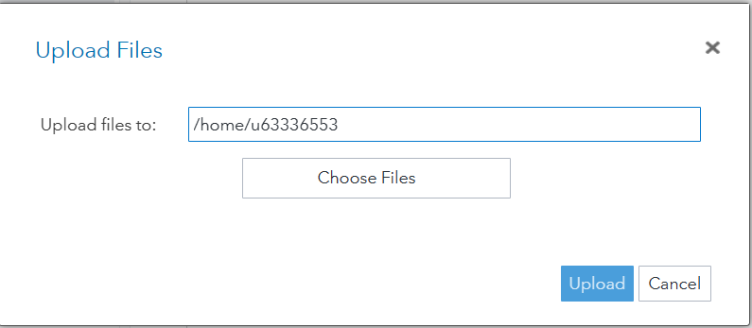

After uploading the files, I select it to open the content shown below.

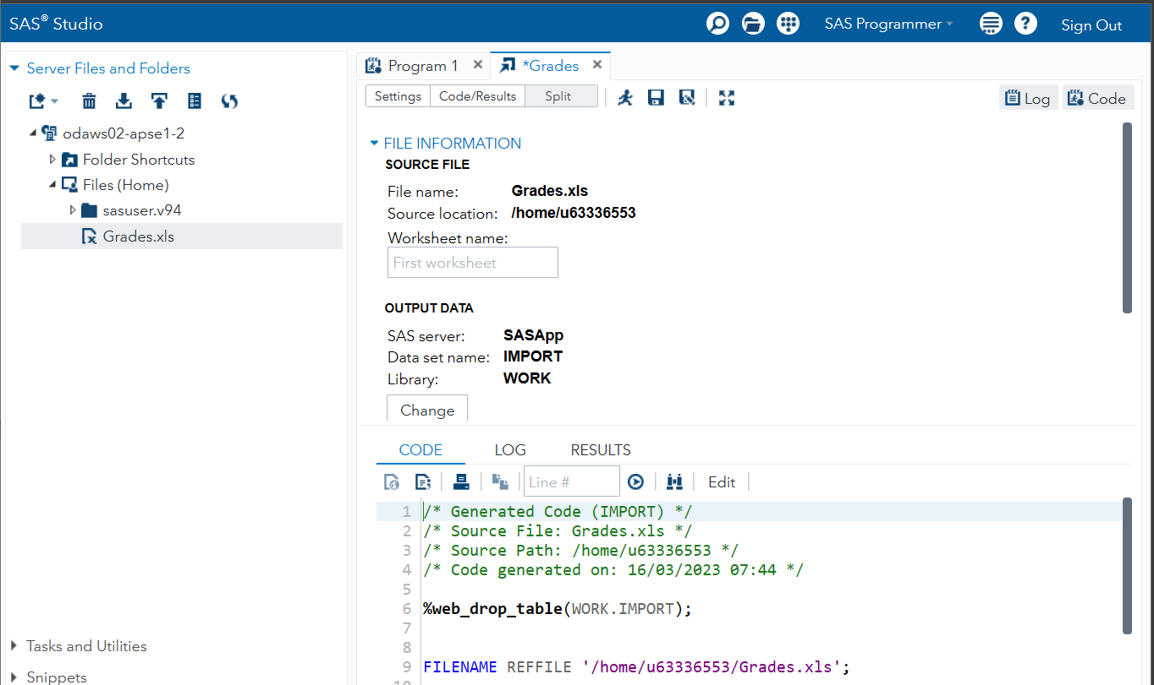

From the above image, it shows that the data set name is “IMPORT”, so I’m going to change its name using the “Change” button.

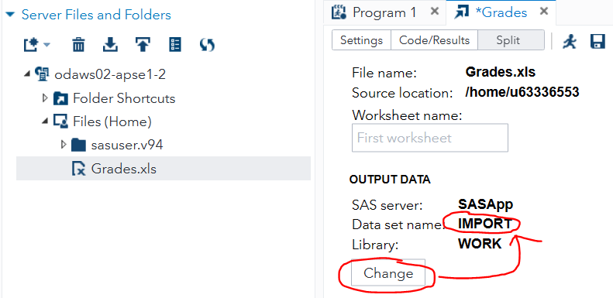

Next, it will show a screen containing SAS libraries and from those libraries, I choose the “WORK” library to save the data set inside as “myGrades”.

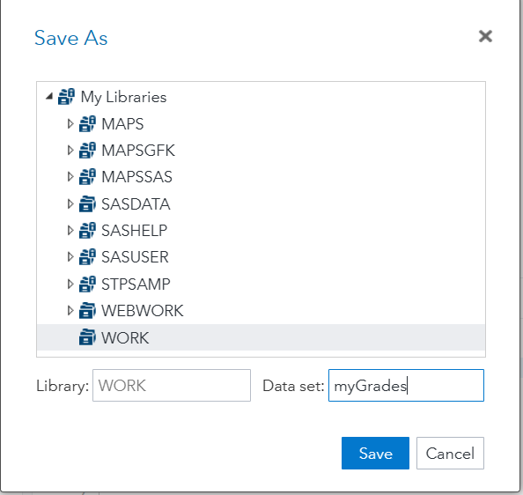

After clicking save the data set name will change as shown

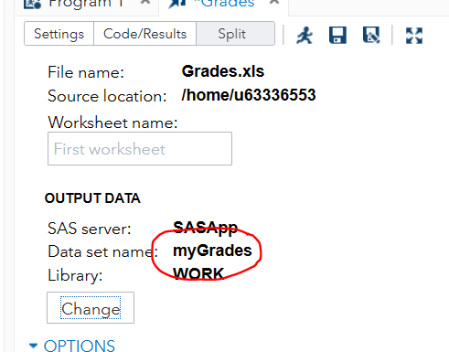

The next step is to open “myGrades” data set from “WORK” library and it will show the grade table.

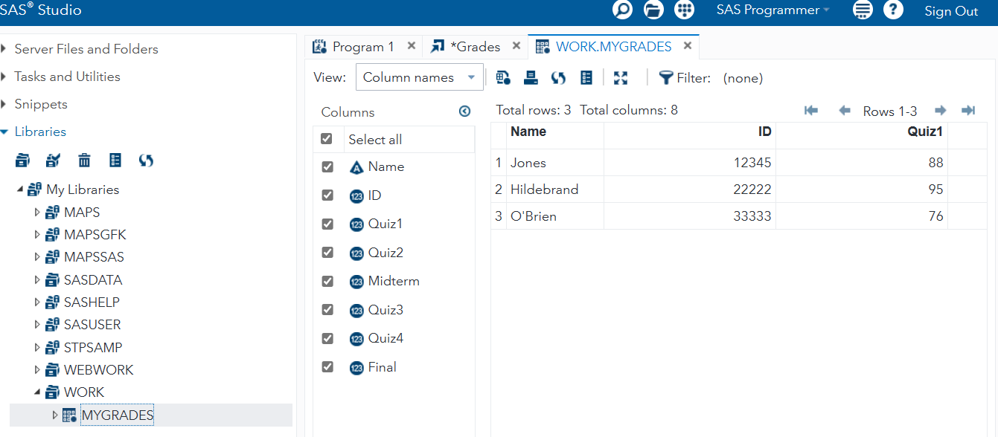

Finally, to create the data report I first select the “Tasks” tab > “Data” > “List Data”. Then select “myGrades” data set on “WORK” library, before running it.

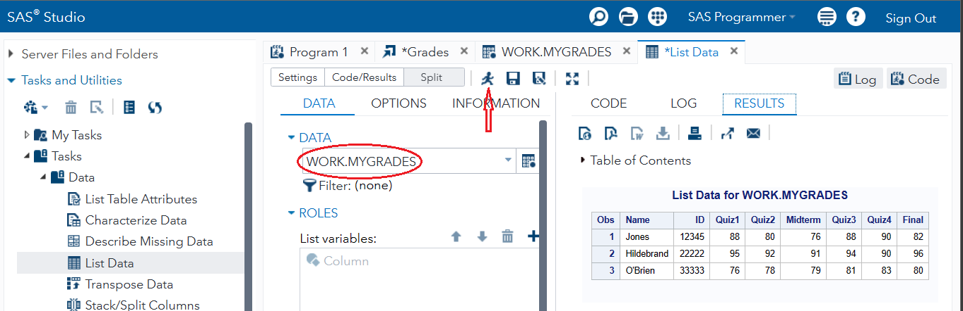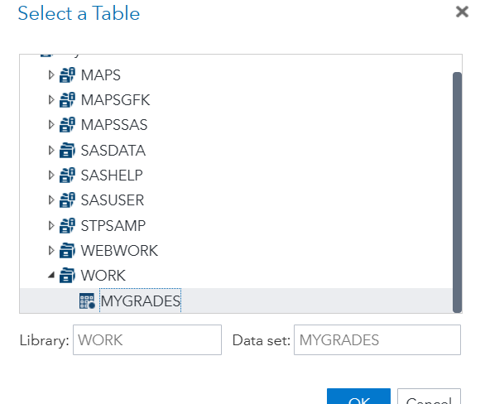

Exercise of Project 2

In this exercise, I begin with creating a simple Listing by first opening “List Data”

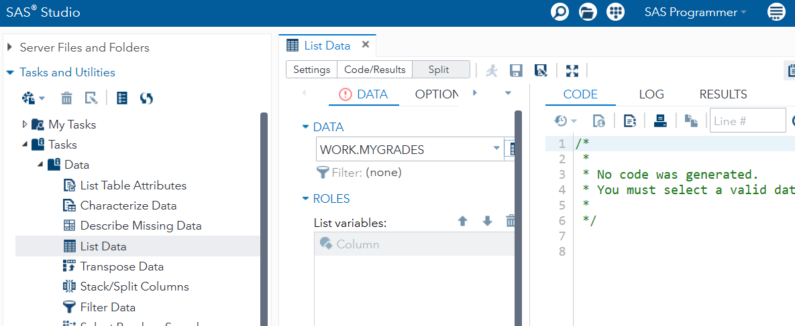

Then select the data set called “Fish” stored in “SASHELP” library.

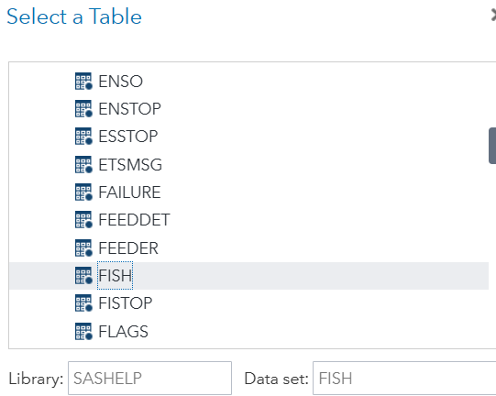

Result after selecting the data set

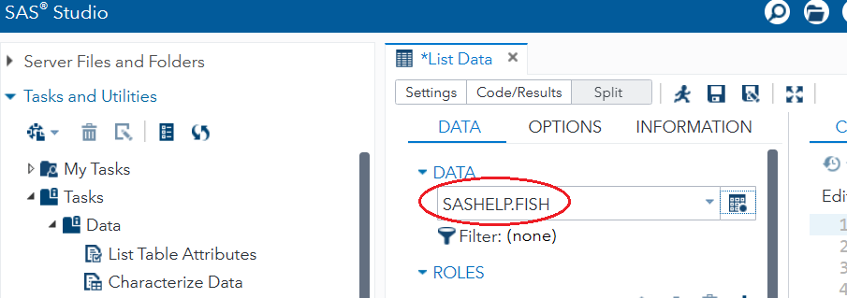

Next, I select variables in the data set Fish and include it variables in the “ROLES” section by clicking the “+” symbol

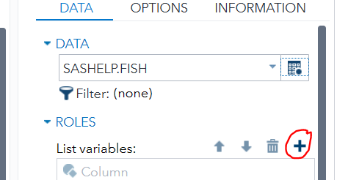

It will then show the screen as shown

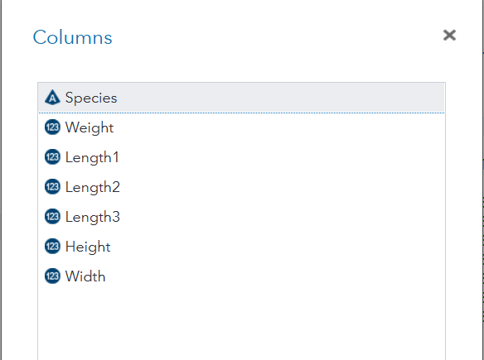

I then choose the listing variables of “Species”, “Weight”, “Height”, and “Width”, and the “ROLES” section will display below

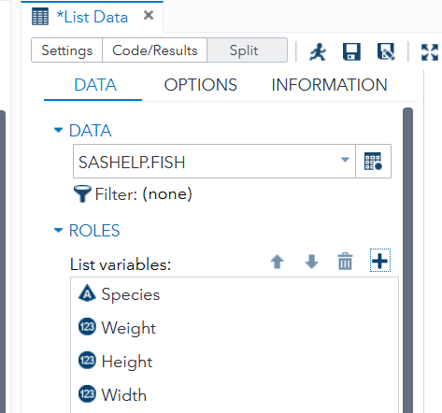

Now using the “OPTION” tab, I can make the data just display the first seven rows in the data set “Fish”

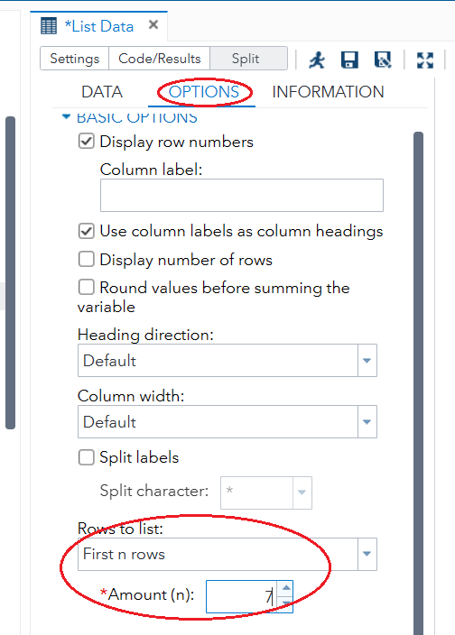

After running the data set it will display the listing results as shown

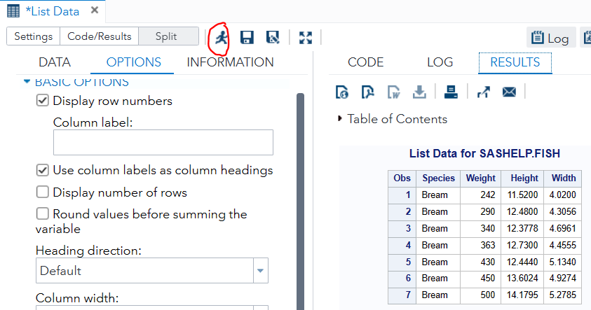

Exercise of Project 3

In this project, I learned how to produce a report such as PDF or RTF file, by using built-in tasks to create a report based on the “Project 2” exercise.

First using the “More Application Options” tab symbol.

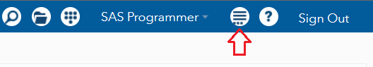

I open the following screen of the “Preferences”

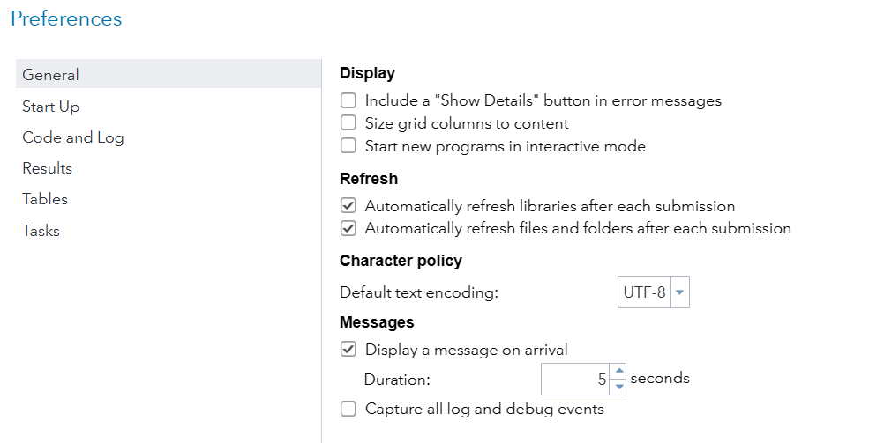

Inside the previous screen, I make sure to select these options, so I can download “Project 2” as PDF file

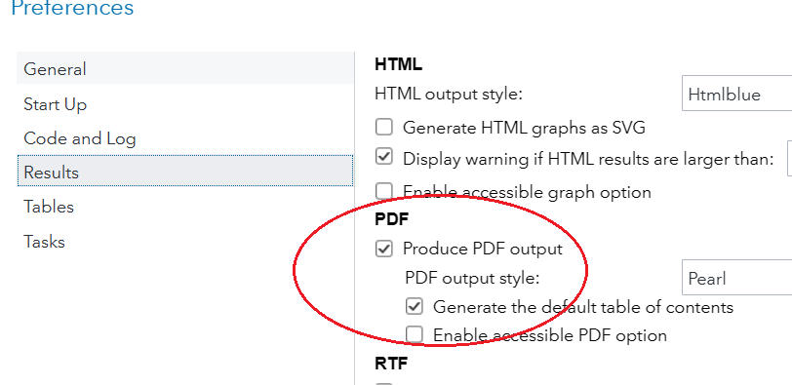

The last thing to be done is to download the “Project 2” results using the download icon

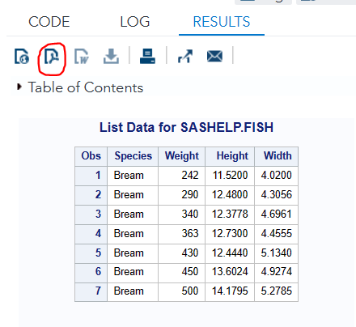

And it will be saved in my computers as PDF file

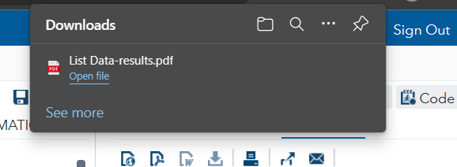

Answering Questions of Week-2 Lab

1. A major characteristic of a DSS and many BI tools (notably those of business

analytics) is the inclusion of at least one model. How does the text describe a

model?

A model basically is the representation of reality, its purpose is to simplify complex reality so it is easy to describe in order to solve a specific problem.

1. Why do some people claim that the choice phase is the point in time when a decision is really made?

Because the choice phase is the step in which the decision to choose a solution and the commitment to follow it are made, it is the phase where we evaluated and recommended many different appropriate solutions to a problem.

These alternatives must be first examined against each other to understand which of them contributes the most towards the goal and what will be achieved by implementing them. By comparing the outcomes of the various alternatives the most appropriate one is chosen, thus this phase is related to deciding the most acceptable choice that fits with the objectives.